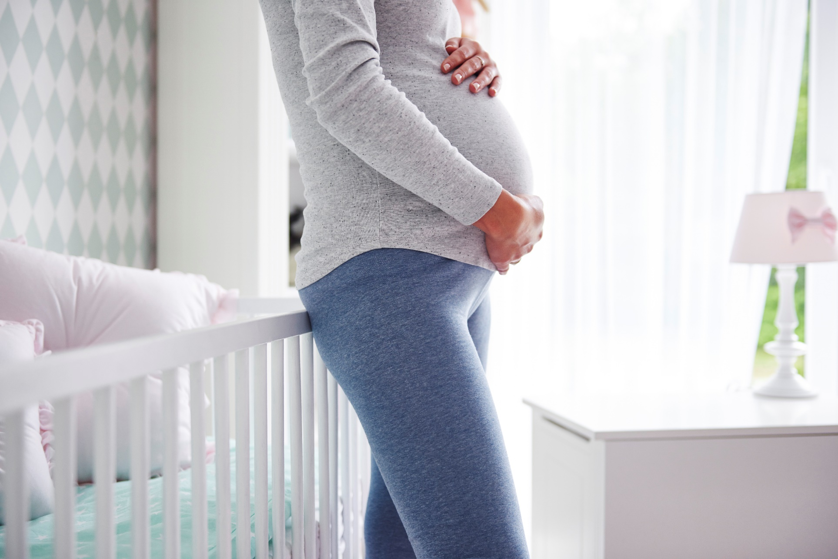**`**

**While Pregnant**

* *Learn about appropriate weight gain*
* *Eat a balanced diet and take prenatal vitamins*
* *Continue exercising with modifications as needed*
* *Practice mindfulness and manage stress*
* *Continue to see a dentist for oral health*

**When Trying to Get Pregnant**

* *Schedule a check-up with your doctor before trying to conceive*
* *Clean out your medicine cabinet*
* *Increase intake of vitamins and veggies*
* *Talk to your partner about how to maximize the likelihood of conception*

**1**

**Things to Know about Preparing for Conception, Pregnancy and Delivery**

**3**

**3**

**Before Childbirth**

*Preparing for childbirth can help you understand your options before giving birth.*

* *Take a childbirth class with your partner or a support person*
* *Develop an ideal birth plan, with an understanding that things may change*
* *Consider finding a doula to support your labor and delivery*

**2**

This information is made available in part by support from the Maternal Health Network (MHN) of San Bernardino County in partnership with **[insert partner name]**. Published in 2021.

To learn more about the MHN, please visit our website at [www.maternalhealthnetworksbc.com](http://www.maternalhealthnetworksbc.com).

**INSERT PARTNER LOGO**

**Presented by [name], [organization]**

Insert two sentence biography of subject matter expert.