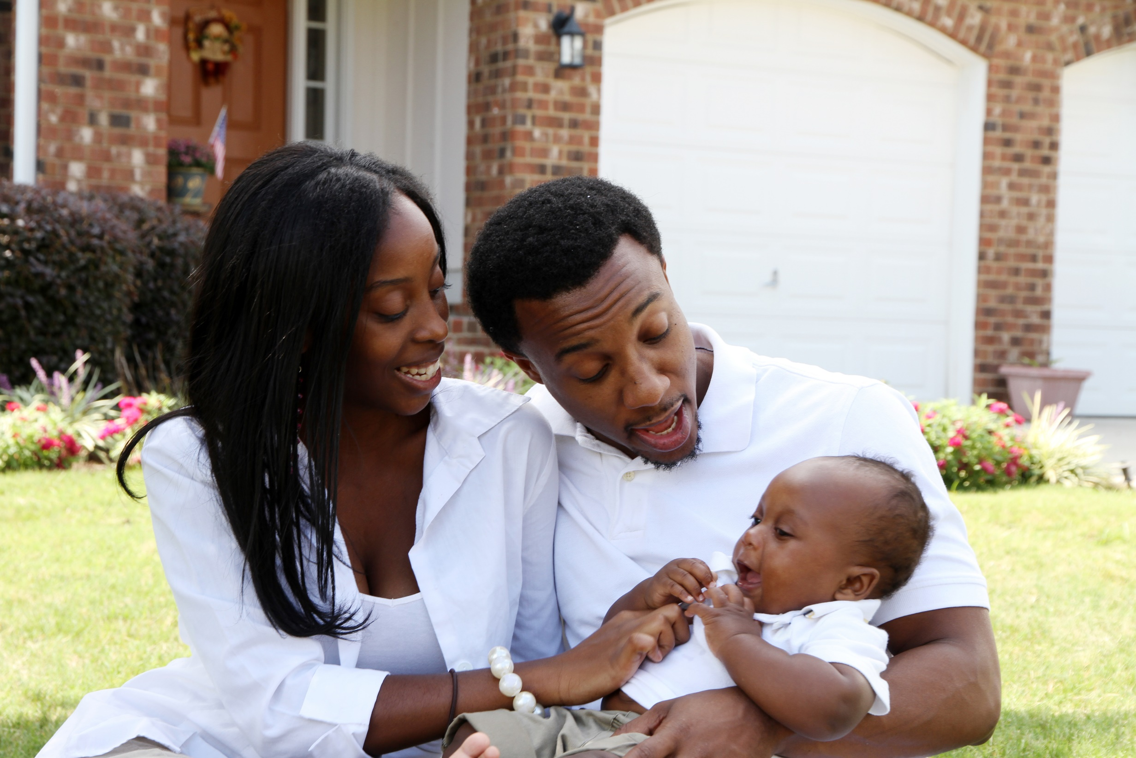****

**Make a Plan**

Make a plan to prepare your home.

* Ensure access to safe water and stable electricity
* Sanitize hard surfaces
* Make sure the crib is assembled correctly
* Secure bathrooms and kitchen cabinets
* Secure or move heavy objects
* Ensure household products are kept in locked cabinets

**2**

**Emotionally Prepare**

Just as with the physical preparation for the home, parents must emotionally prepare for a new baby in the home, including:

* Changes in your relationship
* Postpartum health
* Breastfeeding

**1**

**Identify & Access Your Support System**

* Identify family members, friends, neighbors, community members, and other resources that can help you prepare for your new baby and how.

**3**

This information is made available in part by support from the Maternal Health Network (MHN) of San Bernardino County in partnership with **[insert partner name]**. Published in 2021.

To learn more about the MHN, please visit our website at [www.maternalhealthnetworksbc.com](http://www.maternalhealthnetworksbc.com).

**INSERT PARTNER LOGO**

**Things to Know about Preparing a Safe Home for Baby**

**3**

**Presented by [name], [organization]**

Insert two sentence biography of subject matter expert.