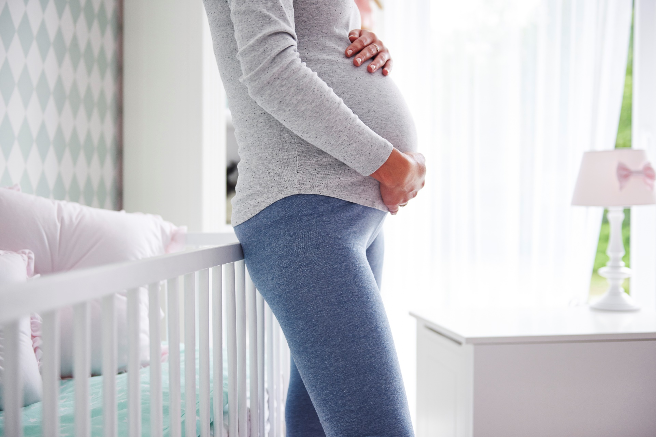

**[Insert Date and Time]**

Please join us to learn a little bit about physical preparation for pregnancy and delivery. The gathering will provide useful information and an opportunity to discuss the following topics with [insert audience]:

* Preparing for Pregnancy
* Nutrition, Exercise, and Mindfulness During Pregnancy
* Childbirth Preparation

**Physical Preparation for Pregnancy and Delivery**

*If you or someone you know would like support with or more information about physical preparation for pregnancy and delivery, please call* ***[insert resource name & contact information].***

**Presented by [name], [organization]**

Insert two sentence biography of subject matter expert.

This information is made available in part by support from the Maternal Health Network of San Bernardino County.

Published in 2021. To learn more about the MHN, please visit our website at [www.maternalhealthnetworksbc.com](http://www.maternalhealthnetworksbc.com).

**Insert Logo and/or Picture of Presenter**